**COMSATS University, Islamabad**

Assignment # 1

Virtual Reality / Augmented Reality Applications

Author: Muhammad Mujtaba

SP22-BSE-036

Course: ICT (CSC-101)

Instructor: Mam Hufsa Mohsin

Date: March 10, 2022

Introduction

AR stands for Augmented Reality and VR stands for Virtual Reality. Both technologies are used to bridge the digital and physical world. This is done through the use of enhanced 3D visuals by these technologies. Although both technologies are similar, but there is some distinction between the two, addressed below.

1. AR

AR morphs the physical world into a colorful visual world by projecting virtual pictures and characters through a phone's camera or video viewer. Augmented reality is merely adding to the user's real-life experience.

1. VR

VR uses same components but produces entirely computer-generated simulation of the alternative world. These immersive simulations can create almost any visual or place imaginable for the player using special equipment such as computers, sensors, headsets, and gloves.

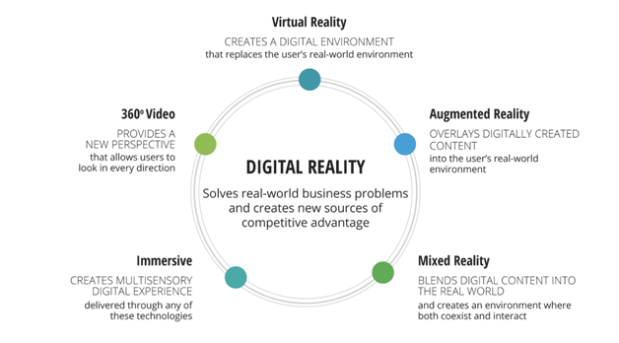

Figure 1: The brief summarization of all digital reality technologies. AR and VR are just two of their types

Domains

AR/VR technologies are currently being used in following domains:

1. Education
2. Games
3. Marketing
4. Real estate
5. HR
6. Space exploration
7. Manufacturing
8. Healthcare
9. Journalism
10. Retail
11. Automotive
12. Modelling and Design

Although there are many domains in which AR/VR is in use, but we will restrict ourself to only two of them.

AR/VR in Education

AR/VR technologies are a promising addition to the “edtech” space due to their immersive nature, ability to share information in new and engaging ways, and potential to offer virtual experiences that can mitigate barriers from cost or distance.

Although still in its early stages, there are many promising examples of this technology already in use in K-12, higher education, and teacher training. Applications range from STEM education and technical training to arts and humanities.

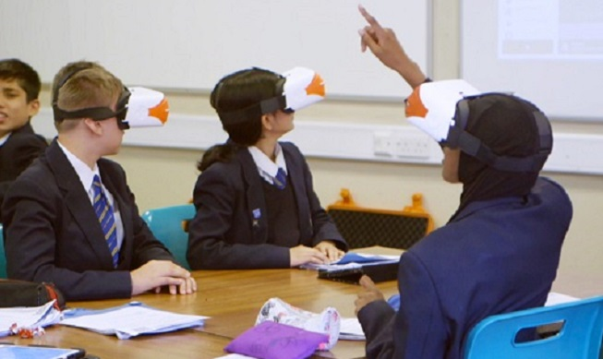

Figure 2 shows a classroom VR environment.

1. Technology

Immersive technologies have the potential to create more engaging, effective, and equitable learning environments for children. Current solutions in this space include libraries of immersive content suitable for educational use, specialized content for targeted subjects and learning levels, and tools developed specifically to support students with learning disabilities.

1. Types of Systems

Due to the rising popularity of mobile devices globally, the widespread use of AR on mobile devices such as smartphones and tablets has become a growing phenomenon. Therefore, mobile devices has a very high potential in AR/VR based education. Numerous other systems can also be used for such purpose, particularly those developed specifically for this.

1. Connection & Configurations

As AR/VR are relatively new technologies, and require complex 3D computations, these technologies are only available for high-end machines only. So these technologies particularly require GPU-based computations in order to work fairly.

1. Benefits

These technologies are very useful in general for educational purposes:

1. Improve the understanding level of students
2. Improve teaching skills in teachers using VR by providing a deep level of knowledge.
3. Improving memory power by connecting feelings with education.
4. It takes very little time to understand very complex topics.
5. Get education as per the book syllabus with its connecting environment and practicals.
6. Fun, Virtual tour, and existing game-based education.
7. Improve a Student’s Imagination power.

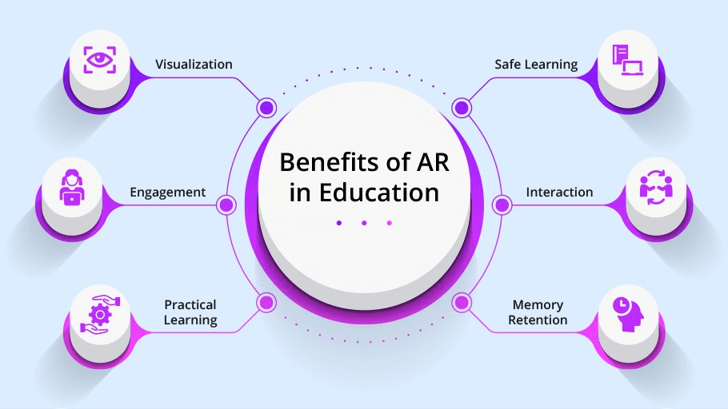

1. Drawbacks

Following are the major drawbacks of these technologies in education field:

1. AR/VR is an expensive technology and require different kinds of configurations in order to work. Institutions cannot afford the expenses of using this technology in bulk quantity.
2. It cannot be used seamlessly with other learning mechanisms because it separates a person with reality.
3. It is relatively new and subject to many tests before being approved as a standard.

AR/VR in Medical Field

VR is an innovative method of training for the medical group. It can be used for a range of diseases in providing adequate medical communication. In orthopaedics, it is used to identify and study the bone fracture. Young doctors can now conduct surgery digitally with step by step learning. VR glasses helps to increase the quality and performance of operation.

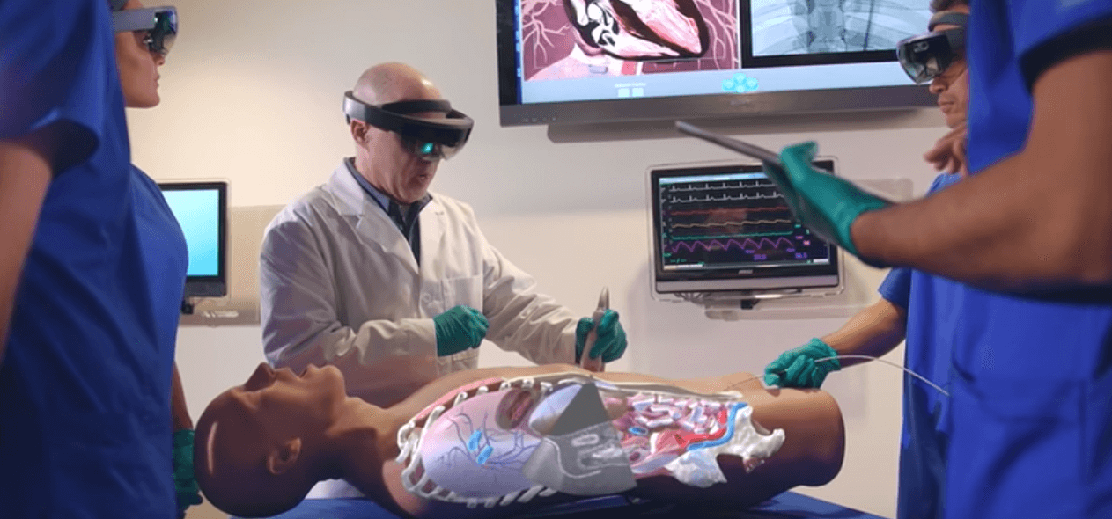

Figure 3 shows surgery learning through the use of VR.

1. Technology

VR technologies have distinct elements like display, optics, eye tracking, motion tracking, head tracking and audio device to provide live sound. In the medical field, it encompasses robotic surgery, surgery simulation, phobia treatment, and skills training. This technology provides better information in optimized time and cost. It is used for presenting complex and innovative ideas regarding treatment.

1. Types of Systems

Different hardware and software are used to create 3D virtual data that creates a 3D virtual environment. The virtual reality of the required medical data is created and identified with the best possible procedure. This procedure is applicable to plan the treatment and finally helps to perform the actual surgery.

1. Connections & Configurations

As these are costly, these devices require relatively complex configurations in order to work efficiently. In order to work with CT Scan or other critical technologies, AR/VR needs to be made more efficient than for tasks such as Gaming.

1. Benefits

The today healthcare industry is adopting VR technology for better treatment of the patient, as this technology allows the learning of new skills in a safe environment. It can train new doctors and nurses to learn anatomy, the practice of operation and teaching about infection control. They can now perform a successful operation through virtual data and precisely understand the operation for complex surgery.It helps to build confidence, skill without causing any harm. This figure summarizes all the benefits:

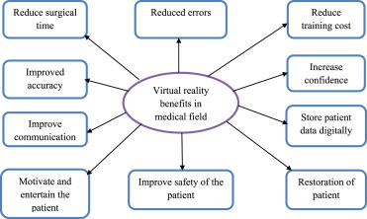

1. Drawbacks
2. The main limitation of this technology is its commercial implementation in the medical field due to its high cost.
3. VR is time-consuming during the treatment and needs extensive software support and hardware support. It requires extra cost for high-resolution patient data.
4. VR images require ample file space to stored data.
5. Currently, this technology is not useful to identify the symptoms of new diseases. It is limited only to understand particular cases and requires proper motion of the body part for the proper treatment.
6. It is limited for the demonstration, and VR headset covers limited areas and body movement of the patient.